## CHAPTER 1

## INTRODUCTION

* 1. **OVERVIEW**

The project aims to empower farmers by providing timely updates on crop conditions through a user-friendly mobile app. Leveraging real-time data from weather forecasts, satellite imagery, and agricultural experts, the app delivers crucial information directly to farmers. Key features include weather alerts, pest and disease notifications, soil health monitoring, and personalized crop management tips. By offering localized and accurate insights, the app helps farmers make informed decisions, optimize resource use, and increase crop yields. This innovative solution not only enhances agricultural productivity but also promotes sustainable farming practices, ensuring food security and improving farmers' livelihoods.

## PURPOSE OF THE PROJECT

The project aims to provide timely updates to farmers through an app, achieving the following purposes: Here are some common purposes:

1. Enhancing Crop Management: By delivering real-time information of the current market prices of each crop in each state there will a better vision to the farmers leading to improved crop management and higher yields.
2. Resource Optimization: The app provides historical data related to each crop resulting in better advisory to the farmers for the management of resources and to alter their production cycles according to the emergencies.
3. Market Connectivity: By keeping farmers updated on market trends and prices, the app aids in better planning of harvest and sale, ensuring farmers receive fair prices for their produce and reducing the dependency on middlemen they will always be aware of what is happening in the global market and resulting in a smooth sale process of their goods.

## MOTIVATION

## Agriculture is the backbone of many economies, yet farmers often struggle with timely access to critical information that can significantly impact their yields and livelihoods. Our project aims to bridge this gap by providing real-time crop updates through an intuitive mobile app. This app empowers farmers with timely alerts on weather conditions, pest infestations, soil health, and market prices, enabling them to make informed decisions and adopt best practices. By leveraging technology to deliver precise, localized information, we aim to enhance productivity, reduce crop losses, and increase profitability for farmers. This initiative not only supports sustainable agricultural practices but also promotes food security and economic stability in rural communities. Our vision is to create a resilient agricultural sector where farmers are equipped with the knowledge and tools they need to thrive in an increasingly unpredictable environment.

## Efficient pricing information enhances economic efficiency across the agricultural value chain. Farmers can optimize planting decisions based on market demand trends, reducing wastage and ensuring a steady income stream. Moreover, it enables better financial planning and risk management, ultimately contributing to sustainable agricultural practices. We collaborate closely with agricultural cooperatives, local governments, and market regulators to ensure the accuracy and relevance of the information provided. This collaborative approach not only strengthens our data sources but also fosters trust within the farming community.

## Our project leverages modern technology, such as IoT devices for data collection and cloud-based analytics, to ensure the reliability and timeliness of price updates. Machine learning algorithms analyze historical data to provide predictive insights, further assisting farmers in making proactive decisions.

**CHAPTER 2**

**LITERATURE SURVEY**

We conducted a thorough literature survey for our Proposed system and thus the following are the defined existing systems for our project:

## EXISTING SYSTEM

There are several existing systems and applications designed to provide timely updates on crop prices for farmers. These systems leverage technology to help farmers stay informed about market conditions and make better decisions. Some of the notable ones include:

1. e-NAM (National Agriculture Market):

An initiative by the Government of India, e-NAM is an online trading platform for agricultural commodities in India. It integrates agricultural markets across the country to create a unified national market for agricultural commodities.

1. AgMarkNet (Agricultural Marketing Information Network):

Another initiative by the Government of India, AgMarkNet provides daily market prices for various agricultural commodities across different states.

1. Kisan Suvidha:

This mobile application by the Ministry of Agriculture and Farmers Welfare of India provides information on weather, market prices, plant protection, input dealers, and agri-advisories to farmers.

1. mKisan:

## An SMS-based portal that disseminates information related to agriculture to farmers, including crop prices, weather updates, and agricultural advisories

1. Krishi Vigyan Kendra (KVK):

Developed by the Indian Council of Agricultural Research (ICAR), this app provides information on crop prices, weather, and other agricultural advisories to farmers.

1. IFFCO Kisan Agriculture App:

This app offers various services including mandi prices, weather forecasts, agricultural advice, and a helpline for farmers.

1. RML AgTech:

Offers a suite of mobile-based services providing information on market prices, weather updates, agricultural tips, and news.

1. FarmBee:

An app by RML AgTech, it provides real-time market prices, weather updates, crop advisories, and other relevant information for farmers.

1. AgroStar:

This app provides farmers with updates on crop prices, weather forecasts, and personalized agricultural advice based on their location.

1. T-Hub's Kalgudi:

An agricultural platform that provides farmers with information on market prices, weather forecasts, and connects them with various stakeholders in the agricultural value chain.

## LIMITATIONS OF EXISTING SYSTEM

Market insight systems, though being crucial in the global arena have some limitations and challenges. it's important to be aware of these limitations to understand the current state of the technology and areas where improvements are needed, therefore here are some common limitations of existing face recognition systems:

**1.Limited Coverage:** Existing systems may have limited coverage, particularly in remote or rural areas where access to market information infrastructure such as internet connectivity, mobile networks, and transportation is inadequate. As a result, farmers in these areas may not receive timely updates on crop prices.

**2.Inaccurate or Outdated Information:** Some existing systems may suffer from inaccuracies or delays in reporting crop prices, leading to unreliable information for farmers. This can occur due to factors such as manual data collection methods, lack of transparency in reporting, and insufficient validation mechanisms.

**3.Limited Interactivity:** Many existing systems for providing crop price updates offer one-way communication channels such as websites, SMS alerts, or radio broadcasts, which do not allow farmers to interact or engage with the information provided. This limits the ability of farmers to seek clarification, ask questions, or provide feedback on market conditions.

**4.Dependency on External Sources:** Some existing systems rely heavily on external sources of information such as government agencies, market intermediaries, or private companies, which may not always prioritize the needs and interests of smallholder farmers. This dependency can lead to biases, conflicts of interest, or disruptions in data availability.

**5.Cost and Affordability:** Accessing information through existing systems may incur costs for farmers, such as data charges for mobile internet or subscription fees for premium services. These costs can be prohibitive for small-scale farmers with limited financial resources, reducing their ability to benefit from timely updates on crop prices.

Addressing these limitations requires a holistic approach that combines technological innovation, community engagement, capacity building, and policy support to ensure that all farmers, regardless of their location or socioeconomic status, have access to timely and reliable information on crop prices.

## CHAPTER 3

**PROPOSED SYSTEM**

## 

* 1. **PROPOSED SYSTEM**

The proposed system aims to empower farmers with timely and accurate crop updates through a user-friendly mobile application. Key features include real-time weather forecasts, pest and disease alerts, market prices, and best agricultural practices tailored to local conditions. The app will offer personalized recommendations based on data analytics and expert insights, ensuring farmers can make informed decisions to optimize crop yields and quality. User engagement will be fostered through interactive features such as forums for knowledge sharing and direct consultations with agricultural experts. Continuous updates and enhancements based on user feedback will drive the app's evolution, ensuring it remains a valuable tool for improving farming efficiency, sustainability, and economic outcomes for farmers.

## OBJECTIVES OF PROPOSED SYSTEM

The objectives of the proposed system include the following:

**Market Prices:**

The application will provide real-time updates on market prices for various agricultural commodities. Farmers can easily access information on the current prices in local markets as well as regional and national markets.

**Demand Forecast:**

Agricultural Insights will analyze historical data and market trends to provide farmers with demand forecasts for different crops and livestock. This information will help farmers plan their production accordingly to meet market demand.

**Weather Updates:**

Weather plays a significant role in agriculture. The app will provide weather forecasts tailored to the farmer's location, helping them make decisions related to planting, harvesting, and crop management.

**Crop Advisory:**

The app will offer crop advisory services, providing recommendations on crop selection, planting techniques, pest and disease management, and best agricultural practices based on local conditions and market demand.

## .3.3 SYSTEM REQUIREMENTS

Here are the requirements for developing and deploying the application.

## SOFTWARE REQUIREMENTS

Below are the software requirements for the application development:

* + - 1. The required language is flutter and dart
      2. Editor Android studio(Flamingo version)
      3. Git GUI
      4. Firebase Project
      5. Pubsec.yaml file
      6. .json files
    1. **HARDWARE REQUIREMENTS**

Below are the hardware requirements for the application development:

* + - 1. Operating System : windows
      2. Processor : intel i3(min)
      3. Ram : 4 GB(min)
      4. Hard Disk : 250GB(min)

## FUNCTIONAL REQUIREMENTS

To design an app that provides farmers with timely updates on market prices and weather, ensuring they gain awareness and improve their financial status, you would need to consider the following functional requirements:

**1. Market Updates:**

- Real-time Data: The app should fetch real-time market prices for various crops and livestock from reliable sources.

- Customization:

Farmers should be able to customize the types of updates they receive based on their specific crops or products of interest.

- Historical Data:

Access to historical pricing trends to help farmers make informed decisions.

**2. Weather Updates:**

- Current Conditions:

Provide current weather conditions for the farmer's location, including temperature, humidity, wind speed, and precipitation.

- Forecasts:

Offer short-term (daily) and medium-term (weekly) weather forecasts to help farmers plan their activities.

- Alerts:

Notify farmers of severe weather conditions (like storms, frosts, etc.) that could affect their crops or livestock.

**3. Geolocation Services:**

- Location-Based Updates:

Automatically fetch updates relevant to the farmer's location, ensuring accuracy and relevance.

- Mapping:

Integration with maps to show weather patterns and market prices geospatially.

**4. User Interface (UI) and Experience (UX):**

- Intuitive Design:

User-friendly interface that is easy for farmers to navigate, especially considering potential low-tech literacy.

- Accessibility:

Ensure the app is accessible via smartphones and possibly SMS for farmers without smartphones.

- Offline Access:

Allow farmers to access previously fetched data and basic functionalities when offline.

**5. Notifications and Alerts:**

- Customizable Alerts:

Farmers should be able to set preferences for receiving alerts about market price changes or weather updates.

- Push Notifications:

Instant notifications sent to the app or via SMS in case of critical updates.

**6. Data Integration and Analysis:**

- Integration with External APIs:

Connect with reliable APIs for market data and weather forecasts.

- Analytics:

Provide basic analytics or insights on trends and patterns in market prices and weather conditions.

## NON-FUNCTIONAL REQUIREMENTS

Non-functional requirements for a mobile application providing real-time market and weather updates for farmers would typically include:

1. **Performance:**

- Responsiveness:

The app should respond quickly to user interactions and data updates, even under varying network conditions.

2. **Reliability:**

- Availability:

The app should be available and accessible to users reliably, minimizing downtime.

- Fault Tolerance:

It should gracefully handle and recover from errors, ensuring minimal disruption to users.

3. **Security:**

- Data Security:

Ensure the confidentiality and integrity of user data, especially personal and financial information.

- Authentication and Authorization:

Implement secure login mechanisms to authenticate users and ensure they have appropriate access permissions.

4. **Compatibility:**

- Device Compatibility:

The app should work seamlessly across different mobile devices (smartphones and tablets) and operating systems (iOS, Android).

5. **Performance Efficiency:**

- Optimised Data Usage:

Minimise data usage to reduce costs for users, especially in regions with limited data connectivity.

## CONCEPTS USED IN THE PROPOSED SYSTEM

The proposed system for providing timely updates of crop information to farmers through an app incorporates several key concepts to ensure its functionality, usability, and effectiveness in agricultural contexts.

**1. Real-time Data Integration:** The app integrates real-time data sources such as weather forecasts, market prices, and pest/disease alerts. This ensures farmers have up-to-date information to make informed decisions promptly.

**2. Personalization and Customization:** The system allows for personalized recommendations based on specific crop types, geographic locations, and individual farm conditions. Farmers receive tailored advice and alerts relevant to their unique situations.

**3. Mobile Accessibility: Designed for mobile devices:** the app ensures accessibility in rural areas with varying network connectivity. It features an intuitive interface that is easy to navigate, even for users with limited technical expertise.

**4. Feedback Mechanism:** Incorporating a feedback loop where farmers can provide input on the usefulness and functionality of the app. This continuous improvement process helps refine features and enhance user satisfaction.

By integrating these concepts, the proposed system aims to empower farmers with timely, relevant information, fostering improved decision-making, sustainable farming practices, and ultimately, enhanced agricultural productivity and livelihood.

## DATA SET USED IN THE PROPOSED SYSTEM

In designing a system that provides timely market price updates on crops for farmers, the choice of a suitable dataset is crucial. Here’s a breakdown of the types of data sets that would be integral to such a system: Here's an overview of the key elements in the data setup for a face recognition system:

**1. Historical Price Data:** This includes historical records of crop prices over time, ideally segmented by region and market. This data helps in analyzing price trends, seasonal variations, and price volatility, which are essential for farmers.

**2. Real-Time Market Data:** Live or near-real-time data feeds from agricultural markets across different regions. This data should include current prices of various crops, updated frequently throughout the trading day.

**3.Weather Data:** Weather conditions significantly impact crop yields and prices. Integrating weather data such as temperature, precipitation, and humidity can provide farmers with insights into potential supply shocks or favorable growing conditions.

**4.Crop Production Data:** Data related to crop production forecasts, acreage under cultivation, expected yields, and harvesting schedules. This helps farmers plan their production cycles based on anticipated market demand.

**5. Consumer Demand Trends**: Data on consumer preferences, dietary trends, and market demand for specific crops. This information can guide farmers in choosing which crops to cultivate and when to sell them.

**6. Market Sentiment and News:** Sentiment analysis of news articles, social media, and market reports related to agriculture. This helps in understanding market sentiment and potential price movements.

**7. IoT Sensor Data (Optional):** For more advanced systems, integrating IoT sensor data from farms (e.g., soil moisture levels, crop health indicators) can provide localized insights into crop conditions and potential impacts on prices.

Integrating these diverse datasets requires robust data management and processing capabilities. Techniques such as data cleaning, normalization, and aggregation are essential to ensure the accuracy and reliability of the information delivered to farmers through the system.

By leveraging these datasets effectively, the proposed system can provide farmers with actionable insights and empower them to make informed decisions regarding crop cultivation, pricing strategies, and market participation.

## 

## CHAPTER 4

## SYSTEM DESIGN

* 1. **COMPONENTS OR USERS IN THE PROPOSED SYSTEM**

The various types of users you might encounter:

**Primary User:**

Farmers:

This is the core user group. The application is designed to equip individual farmers, cooperatives, or agricultural businesses with valuable data for decision-making. They would use the app to access features like real-time prices, demand forecasts, and market trends.

**Potential Secondary Users:**

Agricultural Consultants:

These professionals might use the application to stay updated on market trends and provide more informed advice to their farmer clients. They could leverage the application's insights to tailor recommendations for planting, pricing strategies, and aligning production with market demands.

Policymakers:

Government officials responsible for agricultural policies could benefit from the application's data to understand market dynamics and develop effective policies that support farmers and ensure market stability. Access to insights on production levels, demand forecasts, and price trends would be valuable for informing agricultural policy decisions.

Distributors:

Distributors who purchase agricultural products might use the application to gain insights into future market trends and adjust their purchasing strategies accordingly. This could help them anticipate fluctuations in demand and supply, ensuring they have the right products in stock at the right time.

Consumers (with interest):

While not a core user group, some consumers interested in understanding where their food comes from and how market forces influence food prices might find the application valuable. Access to information on production levels, demand trends, and potentially even origin data could be informative for such users.

## FLUTTER ARCHITECTURE

## 

Flutter is an open-source UI software development kit (SDK) created by Google for building natively compiled applications for mobile (Android and iOS), web, and desktop from a single codebase. Its architecture consists of several layers that work together to create a seamless development experience. Here is a detailed breakdown of Flutter's architecture:

**1. Flutter Engine**

The Flutter Engine is the core of the Flutter framework, responsible for rendering and low-level interactions. It is written primarily in C++ and provides the following functionalities:

* **Skia**: A 2D graphics rendering library used to render all the visual elements.
* **Dart Runtime**: Executes the Dart code. Dart is the programming language used in Flutter.
* **Text Rendering**: Manages complex text layouts.
* **Plugin Architecture**: Enables interaction with the native platform APIs for accessing device features.

**2. Foundation Library**

The Foundation Library is written in Dart and provides core classes and functions, such as:

* **Async Library**: Handles asynchronous programming and futures.
* **Collections**: Includes data structures like lists, maps, and sets.
* **Math and Converters**: Contains mathematical functions and value converters.

**3. Widgets Layer**

Widgets are the building blocks of a Flutter application. They are immutable descriptions of part of the user interface, and Flutter provides two sets of widgets:

* **Material Design Widgets**: Implement Google's Material Design principles.
* **Cupertino Widgets**: Implement Apple's iOS design guidelines.

Widgets manage the configuration and state of the UI elements. There are two types of widgets:

* **Stateless Widgets**: Do not store state and are immutable.
* **Stateful Widgets**: Maintain mutable state that can change over time.

**Differences in How Flutter Works on Android and iOS**

While Flutter aims to provide a unified codebase for both Android and iOS applications, there are some differences in how it works on each platform due to the underlying operating systems and their respective APIs.

**1. Rendering and UI**

* **Android**: Flutter uses Skia to render UI elements directly onto a canvas, bypassing the native Android UI components. This ensures that the look and feel are consistent with the design specifications provided in the Flutter code.
* **iOS**: Similarly, on iOS, Flutter uses Skia to render the UI directly onto a canvas. However, Cupertino widgets are provided to mimic the native iOS design language, ensuring that applications look and feel like native iOS apps.

**2. Platform Channels**

* **Android**: Platform channels on Android use the Java/Kotlin programming languages. Flutter sends messages to and receives messages from the Android platform using these channels. This is used to access platform-specific functionality such as camera, GPS, and other system services.
* **iOS**: On iOS, platform channels use Objective-C/Swift. The communication mechanism remains the same, but the implementation differs due to the language and platform-specific APIs.

**3. Navigation and Lifecycle**

* **Android**: Flutter integrates with Android's activity and fragment lifecycle. This means that Flutter's lifecycle methods map to Android's lifecycle events, such as onCreate, onPause, and onResume.
* **iOS**: Flutter integrates with iOS's view controller lifecycle. The Flutter app lifecycle methods correspond to iOS lifecycle events, such as viewDidLoad, viewWillAppear, and viewDidDisappear.

**4. Build Process**

* **Android**: The Flutter build process for Android involves generating an APK (Android Package) or AAB (Android App Bundle). The build process uses Gradle and integrates with Android Studio for development and debugging.
* **iOS**: For iOS, the build process involves generating an IPA (iOS App) file. Flutter integrates with Xcode for development and debugging, and the build process uses Xcode's build tools.

**5. Native Code Integration**

* **Android**: Flutter allows the inclusion of Android-specific code using plugins or by embedding native Android views. This is useful for integrating third-party libraries or existing native codebases.
* **iOS**: Similarly, Flutter allows the inclusion of iOS-specific code using plugins or by embedding native iOS views. This ensures that developers can access iOS-specific features and libraries.

**6. Performance**

* **Android**: On Android, Flutter leverages the Dart VM (Virtual Machine) during development, providing a hot-reload feature for a faster development cycle. For production, the Dart code is compiled ahead-of-time (AOT) into native machine code, which ensures high performance.
* **iOS**: On iOS, Flutter also uses the Dart VM for development and supports hot-reload. The Dart code is compiled ahead-of-time (AOT) into native ARM code for production, ensuring optimal performance.

## PROPOSED SYSTEM ARCHITECTURE

An architectural diagram outlines the system’s components, their relationships, and system functionality. The application has a complex structure, where we have the user interface, built with the help of Flutter and Dart, which is then integrated with the Firebase as the backend server. The farmer is asked their location, soil and other preferences so that they can be advised the best crops and where to sell them at the best prices.

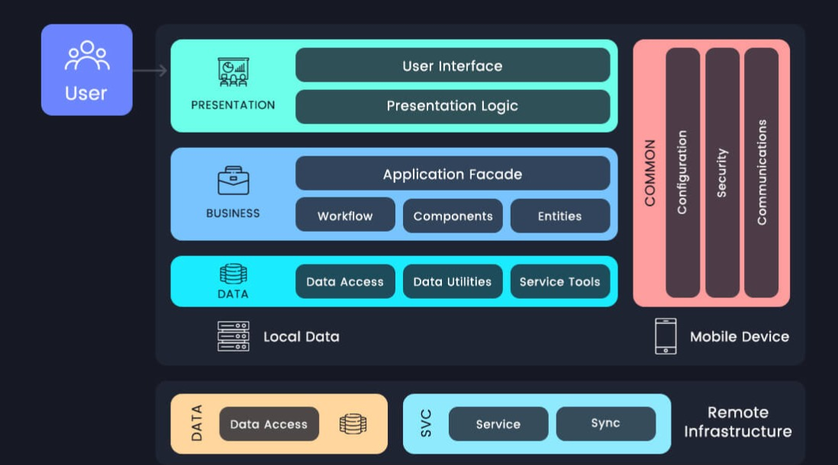

## UML DIAGRAMS:

Creating UML (Unified Modeling Language) diagrams for an application can help in visualizing the system's structure, behavior, and interactions. Below are some commonly used UML diagrams that can be applied:

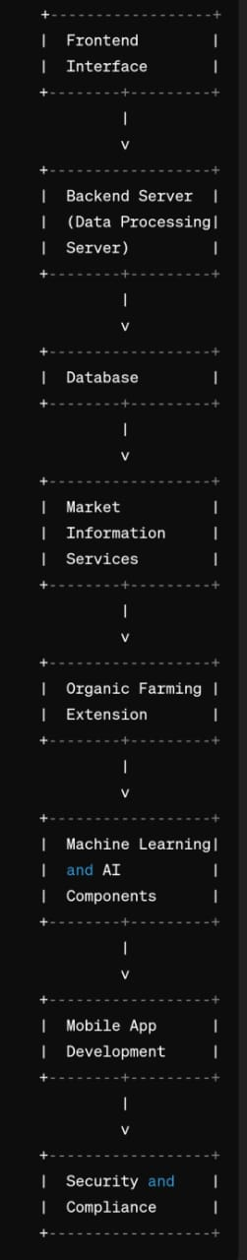

### Use Case Diagram**:**

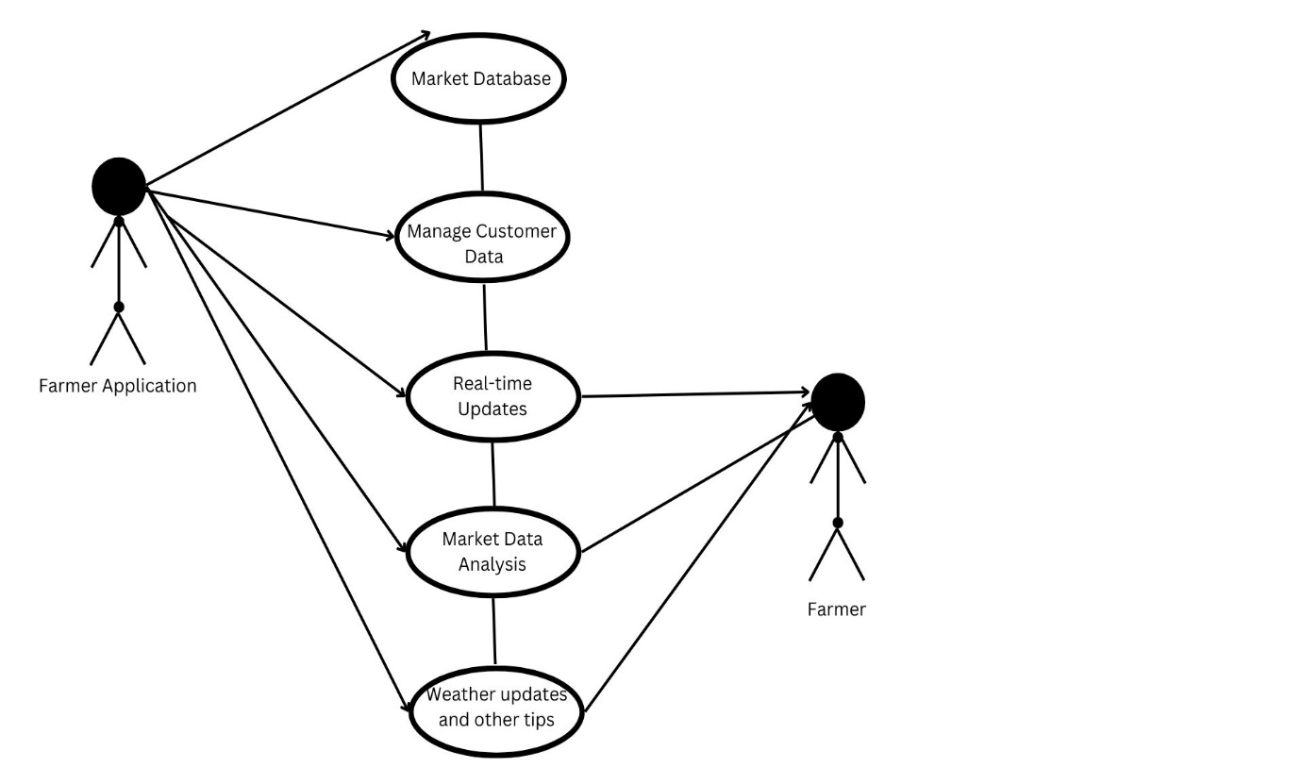

* Identifying various users such as farmer and farmer application.
* Use-Cases are present such as manage customer data, market data analysis and more.
* All of these make up a use-case diagram.

1. **Sequence Diagram:**

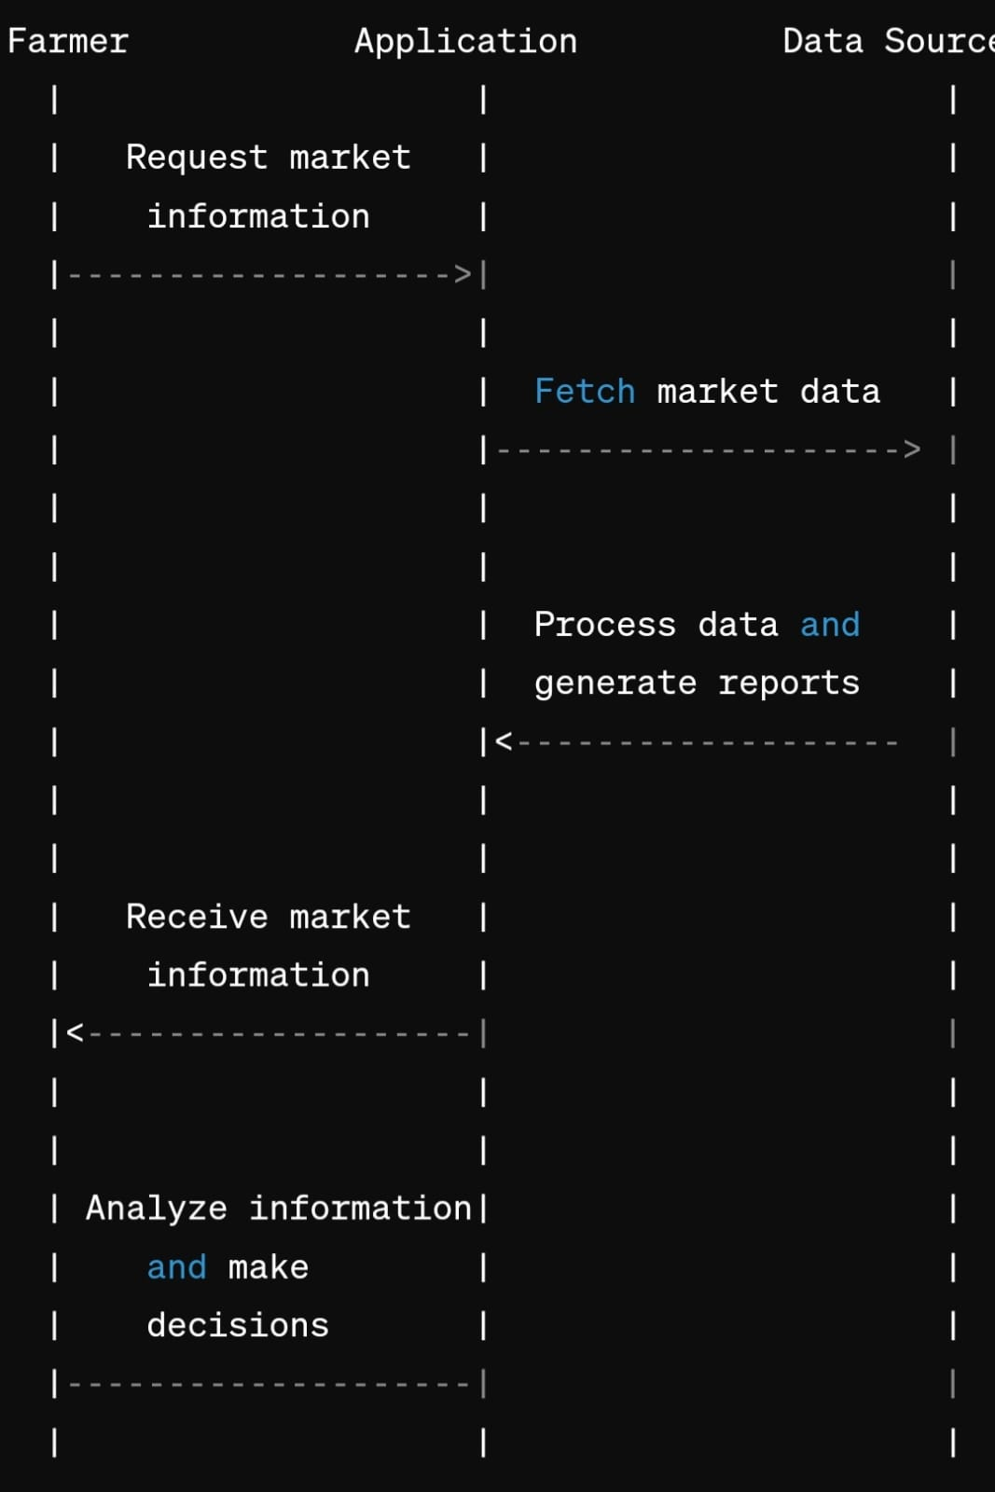

* This diagram shows how the sequence of events in the application takes place.
* First, the farmer requests market information, which is then passed from the application to the data source in such a way that the source generates the required reports.
* These reports are then filtered and then sent back to the farmer who then analyzes the data and makes the required decisions.
  + - 1. **Activity Diagram:**

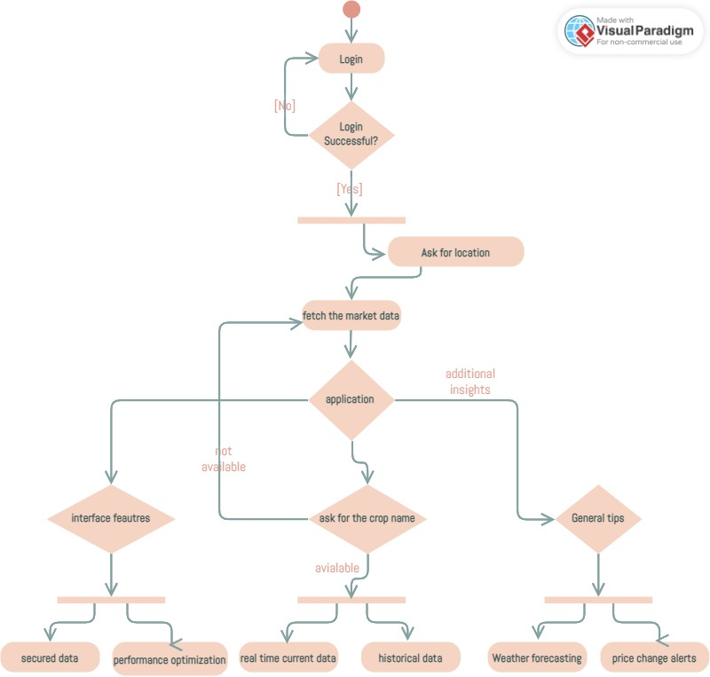

* This diagram shows the various activities present in the application, from the start to the finish.
* These include activities such as logging in, fetching the market data etc.

**FLUTTER AND FIREBASE INTEGRATION:**

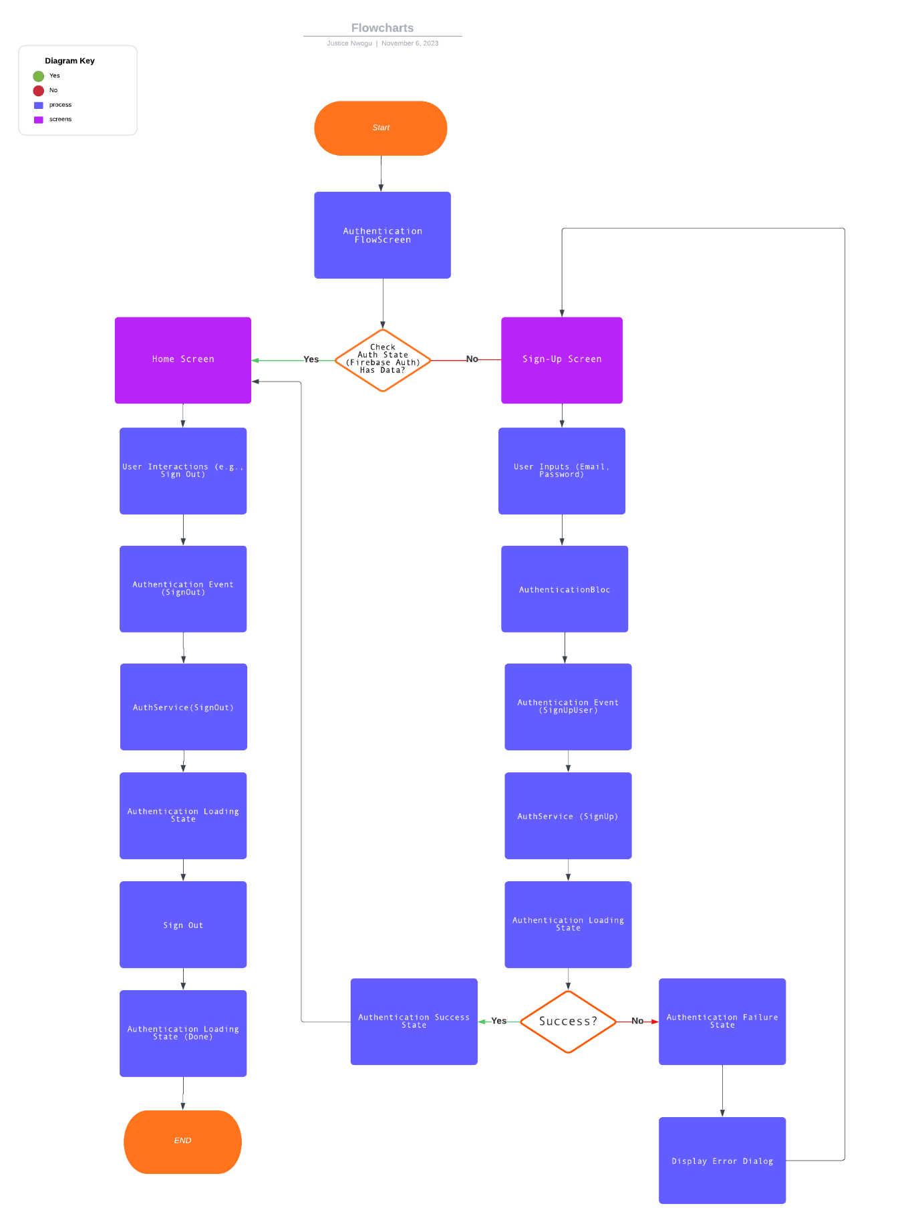

## CHAPTER 5

## IMPLEMENTATION

Implementing an application that gives farmers real-time updates involves several steps, ranging from market information to usage of a backend server. Below is a comprehensive guide with step-by-step instructions for building an application that gives farmers real-time updates using Flutter, Dart and Firebase:

**Frontend Interface:**

User-friendly interface accessible via mobile devices or web browsers.

**Backend Server:**

Real-time data integration from various sources such as market APIs, government databases, and user-generated content.

**Database:**

Storage for user profiles, preferences, and historical market data.

**Market Information Services:**

APIs or data feeds to fetch real-time market prices, demand forecasts, and trends.

**Organic Farming Extension:**

Modular architecture to easily incorporate new features and data sources.

**Machine Learning and AI Components:**

Predictive models for forecasting market trends and demand patterns.

**Mobile App Development:**

Cross-platform compatibility for iOS and Android devices.

**Security and Compliance:**

Encryption protocols to safeguard sensitive user information and transactions.

**5.1 Source Code**

import 'package:flutter/material.dart';

void main() {

runApp(MyApp());

}

class MyApp extends StatelessWidget {

@override

Widget build(BuildContext context) {

return MaterialApp(

title: 'My App',

theme: ThemeData(

primarySwatch: Colors.green,

),

home: FirstPage(),

);

}

}

class FirstPage extends StatelessWidget {

@override

Widget build(BuildContext context) {

return Scaffold(

appBar: AppBar(

title: Text(

'My App',

style: TextStyle(color: Colors.white),

),

backgroundColor: Colors.green,

),

body: Center(

child: Column(

mainAxisAlignment: MainAxisAlignment.center,

children: <Widget>[

Image.asset('assets/logo.png'),

SizedBox(height: 20),

Text(

'Welcome to My App!',

style: TextStyle(

fontSize: 24,

fontWeight: FontWeight.bold,

color: Colors.green,

),

),

SizedBox(height: 20),

ElevatedButton(

onPressed: () {

Navigator.push(

context,

MaterialPageRoute(builder: (context) => LoginPage()),

);

},

style: ElevatedButton.styleFrom(

backgroundColor: Colors.green,

foregroundColor: Colors.white,

shape: RoundedRectangleBorder(

borderRadius: BorderRadius.circular(30.0),

),

padding: EdgeInsets.symmetric(horizontal: 50, vertical: 15),

),

child: Text('Login / Sign Up'),

),

],

),

),

);

}

}

class LoginPage extends StatelessWidget {

final TextEditingController _phoneController = TextEditingController();

final TextEditingController _passwordController = TextEditingController();

User? signedUpUser;

@override

Widget build(BuildContext context) {

return Scaffold(

appBar: AppBar(

title: Text('Login'),

),

body: Padding(

padding: const EdgeInsets.all(16.0),

child: Column(

mainAxisAlignment: MainAxisAlignment.center,

children: <Widget>[

TextField(

controller: _phoneController,

decoration: InputDecoration(labelText: 'Phone Number'),

keyboardType: TextInputType.phone,

),

TextField(

controller: _passwordController,

decoration: InputDecoration(labelText: 'Password'),

obscureText: true,

),

SizedBox(height: 20),

ElevatedButton(

onPressed: () {

// Simulate login success

ScaffoldMessenger.of(context).showSnackBar(

SnackBar(content: Text('Login Successful')),

);

// Navigate to Home Page after successful login

Navigator.push(

context,

MaterialPageRoute(

builder: (context) => HomePage(signedUpUser: signedUpUser),

),

);

},

style: ElevatedButton.styleFrom(

backgroundColor: Colors.green,

foregroundColor: Colors.white,

shape: RoundedRectangleBorder(

borderRadius: BorderRadius.circular(30.0),

),

padding: EdgeInsets.symmetric(horizontal: 50, vertical: 15),

),

child: Text('Login'),

),

TextButton(

onPressed: () {

Navigator.push(

context,

MaterialPageRoute(builder: (context) => ForgotPasswordPage()),

);

},

child: Text('Forgot Password?'),

),

SizedBox(height: 20),

ElevatedButton(

onPressed: () async {

final result = await Navigator.push<User>(

context,

MaterialPageRoute(builder: (context) => SignUpPage()),

);

if (result != null) {

signedUpUser = result;

}

},

style: ElevatedButton.styleFrom(

backgroundColor: Colors.green,

foregroundColor: Colors.white,

shape: RoundedRectangleBorder(

borderRadius: BorderRadius.circular(30.0),

),

padding: EdgeInsets.symmetric(horizontal: 50, vertical: 15),

),

child: Text('Sign Up'),

),

],

),

),

);

}

}

class HomePage extends StatelessWidget {

final User? signedUpUser;

HomePage({this.signedUpUser});

@override

Widget build(BuildContext context) {

return Scaffold(

appBar: AppBar(

title: Text('Home'),

),

body: Center(

child: Column(

mainAxisAlignment: MainAxisAlignment.spaceBetween,

children: <Widget>[

Text('Welcome to the Home Page!'),

Padding(

padding: const EdgeInsets.all(16.0),

child: Row(

mainAxisAlignment: MainAxisAlignment.spaceAround,

children: [

_buildRoundButton(Icons.home, 'Home', context),

_buildRoundButton(Icons.search, 'Search', context),

_buildRoundButton(Icons.notifications, 'Notifications', context, onPressed: () {

Navigator.push(

context,

MaterialPageRoute(builder: (context) => NotificationsPage()),

);

}),

_buildRoundButton(

Icons.person,

'Profile',

context,

onPressed: () {

if (signedUpUser != null) {

Navigator.push(

context,

MaterialPageRoute(

builder: (context) => ProfilePage(user: signedUpUser!),

),

);

} else {

ScaffoldMessenger.of(context).showSnackBar(

SnackBar(content: Text('No user data found')),

);

}

},

),

],

),

),

],

),

),

);

}

Widget _buildRoundButton(IconData icon, String label, BuildContext context, {VoidCallback? onPressed}) {

return Column(

children: [

ElevatedButton(

onPressed: onPressed ?? () {},

style: ElevatedButton.styleFrom(

shape: CircleBorder(),

padding: EdgeInsets.all(20),

backgroundColor: Colors.green,

foregroundColor: Colors.white,

),

child: Icon(icon, size: 30),

),

SizedBox(height: 5),

Text(label),

],

);

}

}

class NotificationsPage extends StatelessWidget {

final List<String> farmingTips = [

'Rotate crops to improve soil health.',

'Use organic fertilizers to enrich the soil.',

'Implement drip irrigation to save water.',

'Practice integrated pest management.',

'Maintain farm equipment regularly.',

];

@override

Widget build(BuildContext context) {

return Scaffold(

appBar: AppBar(

title: Text('Harvest Hub'),

),

body: Padding(

padding: const EdgeInsets.all(16.0),

child: SingleChildScrollView(

child: Column(

crossAxisAlignment: CrossAxisAlignment.start,

children: <Widget>[

Text(

'Emergency Alerts',

style: TextStyle(fontSize: 20, fontWeight: FontWeight.bold),

),

SizedBox(height: 10),

Text('No emergency alerts as of now'),

SizedBox(height: 20),

Text(

'General Tips',

style: TextStyle(fontSize: 20, fontWeight: FontWeight.bold),

),

SizedBox(height: 10),

for (String tip in farmingTips)

Padding(

padding: const EdgeInsets.only(bottom: 8.0),

child: Text('• $tip'),

),

],

),

),

),

);

}

}

class ForgotPasswordPage extends StatefulWidget {

@override

_ForgotPasswordPageState createState() => _ForgotPasswordPageState();

}

class _ForgotPasswordPageState extends State<ForgotPasswordPage> {

final TextEditingController _phoneController = TextEditingController();

final TextEditingController _otpController = TextEditingController();

final TextEditingController _newPasswordController = TextEditingController();

final TextEditingController _confirmPasswordController = TextEditingController();

bool _showOtpField = false;

bool _showPasswordFields = false;

void _sendOTP() {

setState(() {

_showOtpField = true;

});

}

void _verifyOTP() {

setState(() {

_showPasswordFields = true;

});

}

@override

Widget build(BuildContext context) {

return Scaffold(

appBar: AppBar(

title: Text('Forgot Password'),

),

body: Padding(

padding: const EdgeInsets.all(16.0),

child: Column(

mainAxisAlignment: MainAxisAlignment.center,

children: <Widget>[

TextField(

controller: _phoneController,

decoration: InputDecoration(labelText: 'Phone Number'),

keyboardType: TextInputType.phone,

),

SizedBox(height: 20),

ElevatedButton(

onPressed: _sendOTP,

style: ElevatedButton.styleFrom(

backgroundColor: Colors.green,

foregroundColor: Colors.white,

shape: RoundedRectangleBorder(

borderRadius: BorderRadius.circular(30.0),

),

padding: EdgeInsets.symmetric(horizontal: 50, vertical: 15),

),

child: Text('Send OTP'),

),

SizedBox(height: 20),

if (_showOtpField)

Column(

children: [

TextField(

controller: _otpController,

decoration: InputDecoration(labelText: 'Enter OTP'),

keyboardType: TextInputType.number,

),

SizedBox(height: 20),

ElevatedButton(

onPressed: _verifyOTP,

style: ElevatedButton.styleFrom(

backgroundColor: Colors.green,

foregroundColor: Colors.white,

shape: RoundedRectangleBorder(

borderRadius: BorderRadius.circular(30.0),

),

padding: EdgeInsets.symmetric(horizontal: 50, vertical: 15),

),

child: Text('Verify OTP'),

),

],

),

SizedBox(height: 20),

if (_showPasswordFields)

Column(

children: [

TextField(

controller: _newPasswordController,

decoration: InputDecoration(labelText: 'Enter New Password'),

obscureText: true,

),

TextField(

controller: _confirmPasswordController,

decoration: InputDecoration(labelText: 'Confirm New Password'),

obscureText: true,

),

SizedBox(height: 20),

ElevatedButton(

onPressed: () {

ScaffoldMessenger.of(context).showSnackBar(

SnackBar(content: Text('Password Reset Successful')),

);

Navigator.pop(context); // Go back to login page

},

style: ElevatedButton.styleFrom(

backgroundColor: Colors.green,

foregroundColor: Colors.white,

shape: RoundedRectangleBorder(

borderRadius: BorderRadius.circular(30.0),

),

padding: EdgeInsets.symmetric(horizontal: 50, vertical: 15),

),

child: Text('Submit'),

),

],

),

],

),

),

);

**Github link:** https://github.com/loukhyachundi/HARVEST-HUB

**CHAPTER 6**

**RESULTS**

**START PAGE :**

This page consists of the app logo and the login or sign up options.

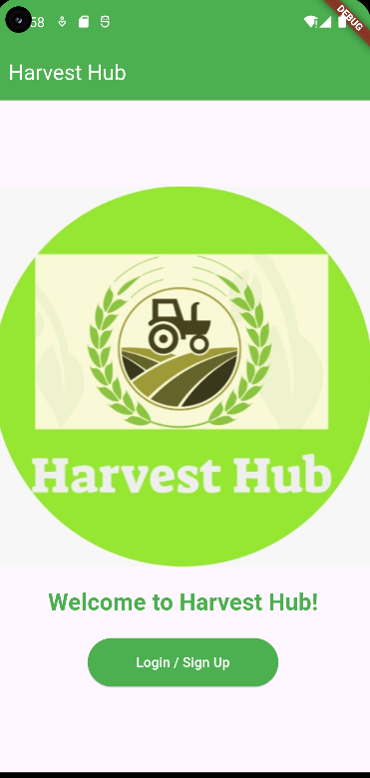

**LOGIN/SIGNUP PAGE:**

This page showcases the options of login or signup and helps the farmers in registering in the database and make for themselves a profile page.

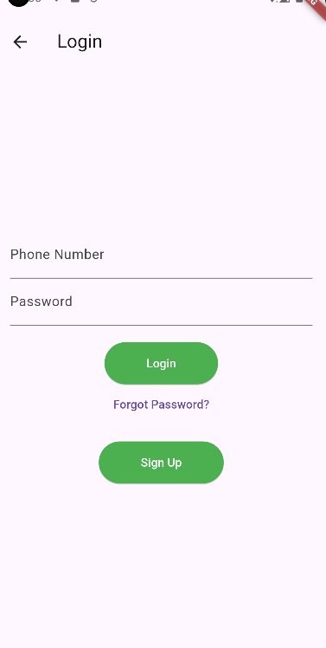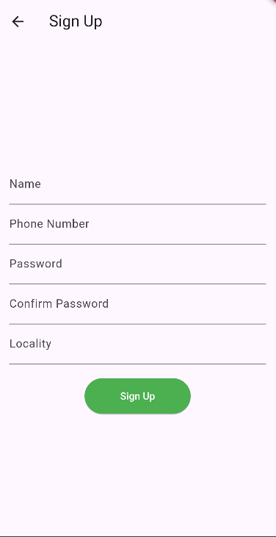

**CHAPTER 7**

**CONCLUSION**

In conclusion, developing an app to provide timely updates on crop prices for farmers holds significant potential to empower agricultural communities and improve market transparency. However, it's crucial to acknowledge the existing limitations of such systems, including coverage gaps, information inaccuracies, accessibility barriers, and technological challenges. Despite these challenges, the benefits of implementing such an app are substantial, including enabling farmers to make more informed decisions about crop sales, negotiate better prices, and mitigate market risks.

**FUTURE ENHANCEMENT**

1. **Enhanced Data Accuracy**: Implement measures to improve the accuracy and reliability of price data, such as integrating real-time market data feeds, leveraging blockchain technology for transparent data recording, and implementing validation mechanisms to ensure data integrity.

2. **Improved Accessibility**: Develop user-friendly interfaces and support multiple languages to enhance accessibility for farmers with varying levels of literacy and technological proficiency. Consider providing offline functionality to accommodate farmers in areas with limited internet connectivity.

3. **Interactive Features**: Introduce interactive features such as chatbots, forums, and helplines to facilitate two-way communication between farmers and market experts. Enable farmers to ask questions, seek advice, and share insights about local market conditions.

4. **Customized Alerts and Recommendations**: Implement personalized alert systems that notify farmers about price fluctuations, market trends, and relevant news updates tailored to their specific crops and geographic location. Provide actionable recommendations based on market analysis and predictive analytics.

5. **Integration with Agricultural Extension Services**: Collaborate with government agencies, NGOs, and agricultural extension services to integrate the app with existing information dissemination channels. Leverage partnerships to reach a wider audience and ensure the app's sustainability and scalability.

6. **Capacity Building and Training:** Offer training programs and capacity-building initiatives to educate farmers about the app's features, functionalities, and benefits. Provide technical support and user assistance to address any challenges or questions farmers may encounter while using the app.

7. **Incentive Mechanisms**: Explore incentivization strategies such as loyalty programs, rewards, or subsidies to encourage farmers to adopt and actively engage with the app. Create incentives for data sharing and participation to enrich the app's ecosystem and improve its overall effectiveness.

By continuously iterating and enhancing the app based on user feedback, technological advancements, and market dynamics, we can create a robust and sustainable platform that empowers farmers to thrive in an increasingly digital and interconnected agricultural landscape.

**REFERENCES**

1. "ICT Applications in Agriculture: Opportunities and Challenges"

*Authors: Qasem, M., et al.*

This paper discusses the potential of ICT applications in agriculture, including the use of mobile apps for providing timely updates on crop prices to farmers.

2. "The Role of Mobile Phones in Agricultural Development: A Review of Agricultural Extension Services in Developing Countries"

*Authors: Kikulwe, E. M., et al.*

This review article examines the role of mobile phones in agricultural development, focusing on the provision of extension services and market information to farmers.

3."Agricultural Market Information Systems in Developing Countries: A Review of the Literature"

*Authors: Abdalla, R. B., & Wailes, E. J.*

This literature review provides an overview of agricultural market information systems in developing countries, highlighting their impact on farmers' access to timely market information.

4. "Using Mobile Phones for Agricultural Extension: A Review of Evidence from Africa"

*Authors: Aker, J. C.*

This paper reviews the evidence on the use of mobile phones for agricultural extension services in Africa, including the dissemination of crop price information to farmers.

5. "ICT for Agriculture in Africa: A Desk Review of Mobile Applications for Agricultural Extension and Advisory Services"

*Authors: Lee, D. R., & Bellemare, M. F.*

This desk review examines the landscape of mobile applications for agricultural extension and advisory services in Africa, with a focus on apps providing crop price updates.

6. "Information and Communication Technologies for Agricultural Development in Developing Countries: A Systematic Review"

*Authors: Suri, S., & Jack, W.*

This systematic review evaluates the impact of information and communication technologies on agricultural development in developing countries, including the role of mobile apps in providing market information to farmers.

7. "ICTs and the Agricultural Sector: Towards Sustainable Rural Development"

*Authors: Adepetu, A., & Adepoju, T. F.*

This paper explores the potential of ICTs in the agricultural sector for promoting sustainable rural development, with a focus on mobile apps for disseminating crop price information.

8. "Role of ICT in Agriculture: A Review of Literature"

*Authors: Keshari, A. K., et al.*

This review article examines the role of ICT in agriculture, including the use of mobile apps for providing market information to farmers, based on an analysis of existing literature.

9. "Mobile Applications for Agriculture and Rural Development: A Review of Literature”

*Authors: Rehman, A., et al.*

This literature review provides an overview of mobile applications for agriculture and rural development, with a focus on apps that offer crop price updates and market information to farmers.

1. "Digital Agriculture: A Review of Literature”

*Authors: Singh, S., & Sharma, D.*

This review paper discusses the concept of digital agriculture and its potential to transform the agricultural sector, including the role of mobile apps in providing timely updates on crop prices to farmers.

These references offer a comprehensive understanding of the existing literature on mobile applications for providing timely updates on crop prices to farmers, which can inform the development and implementation of such an app.